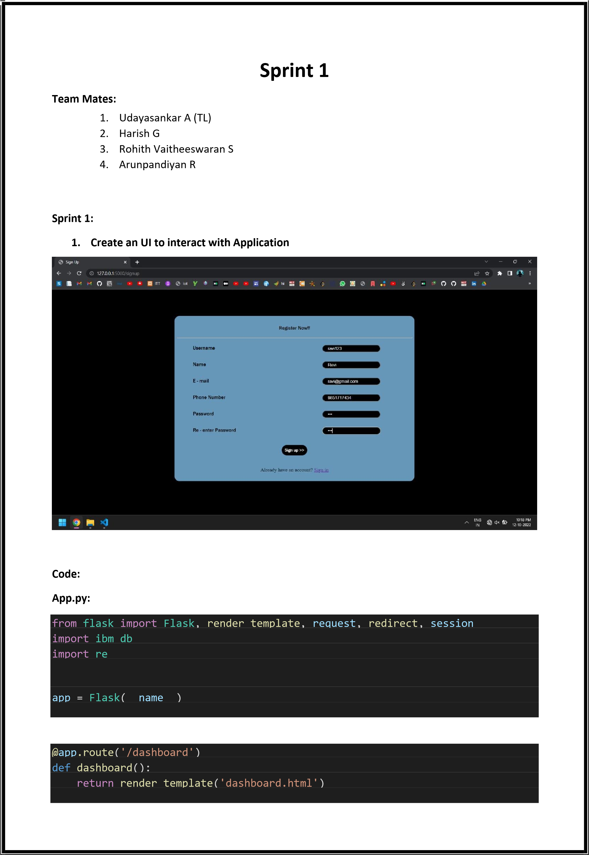

|  |
| --- |
|  |
| @app.route('/admin') def admin(): return render_template('admin.html')  @app.route('/about') def about(): return render_template('about.html')  @app.route('/privacyterms') def privacyterms():  return render_template('privacyterms.html')        **Login.html:**  {% extends 'base.html' %}      {% block head %}    <title>  Login  </title>    {% endblock %}      {% block body %}    <div class="forpadding">    <!-- for box of the signup form -->  <div class="sign">  <div>  <p class="fortitle">  Sign In  </p>  <hr>  <form action="/login" method="post">  <div class="forform">  <div class="textinformleft">  Username |

|  |
| --- |
| </div>  <div class="textinformright">  <input type="name" name="username">  </div>  </div>    <div class="forform">  <div class="textinformleft">  Password  </div>  <div class="textinformright">  <input type="password" name="pass">  </div>  </div>    <br>  <div>  <button class="forbutton" type="submit"> Sign In >></button>  </div>  </form>  <br>    <div>  New user? <a href="/signup">Sign up</a>  </div>  <br>  </div>    </div>  </div>    {% endblock %}      **Base.html:**  <!DOCTYPE html>    <head>    <link rel="stylesheet" href="static/css/main.css"/>  {% block head %} {% endblock %}  </head>    <body>  {% block body %} |



}



{



% endblock %



<



/



body



>



<



/



html



>

